**Day 9 Assignment**

**--Qn1. Create AFTER UPDATE trigger to track product price changes**

**QUERY DETAILS**

--Create product_price_audit table with below columns:

create table product_price_audit (

audit_id serial primary key,

product_id int,

product_name varchar(40),

old_price decimal(10,2),

new_price decimal(10,2),

change_date timestamp default current_timestamp,

user_name varchar(50) default current_user

);

-- Create a trigger function with the below logic:

create or replace function track_price_changes()

returns trigger as $$

begin

insert into product_price_audit (

product_id,

product_name,

old_price,

new_price

)

values (

old.product_id,

old.product_name,

old.unit_price,

new.unit_price

);

return new;

end;

$$ language plpgsql;

-- Create the trigger on products

create trigger after_price_update

after update of unit_price on products

for each row

when (old.unit_price is distinct from new.unit_price)

execute function track_price_changes();

-- Test the trigger by updating the product price by 10% to any one product_id.

update products

set unit_price = unit_price * 1.10

where product_id = 1;

select * from product_price_audit;

**OUTPUT**

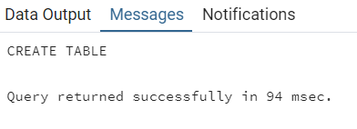

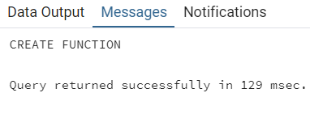

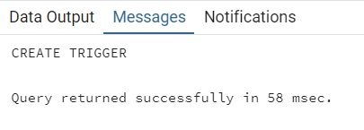

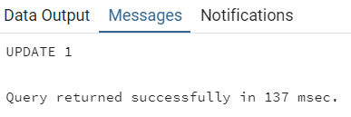

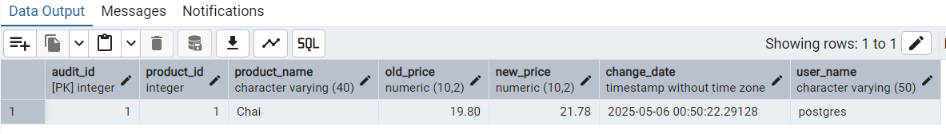

**--Qn2.Create stored procedure using IN and INOUT parameters to assign tasks to employees**

**QUERY DETAILS**

-- Create the employee_tasks table using the Parameters

create table if not exists employee_tasks (

task_id serial primary key,

employee_id int,

task_name varchar(50),

assigned_date date default current_date

);

-- Create the stored procedure

create or replace procedure assign_task(

in p_employee_id int,

in p_task_name varchar(50),

inout p_task_count int default 0

)

language plpgsql

as $$

begin

insert into employee_tasks (employee_id, task_name)

values (p_employee_id, p_task_name);

select count(*) into p_task_count

from employee_tasks

where employee_id = p_employee_id;

raise notice 'Task "%" assigned to employee %. Total tasks: %',

p_task_name, p_employee_id, p_task_count;

end;

$$;

-- After creating stored procedure test by calling it:

call assign_task(1, 'review reports');

-- You should see the entry in employee_tasks table.

select * from employee_tasks;

**OUTPUT**



